Participle (present or past) functions as a modifier

🔹 What Is Participle (present or past) functions as a modifier?
# Source: AI Source: Provided by: [Data Path: Persons Table -> ID Column: 1, Name_En Column: Motasem Essam] -> From: [Chatgpt (GPT‑5 Mini)] on [8/7/2025]
A participle (present or past) functions as a modifier when it describes or gives more information about a noun or pronoun.
It often appears at the beginning or end of a sentence, forming a participle phrase.

🔸 Types of Participles:
# Source: AI Source: Provided by: [Data Path: Persons Table -> ID Column: 1, Name_En Column: Motasem Essam] -> From: [Chatgpt (GPT‑5 Mini)] on [8/7/2025]
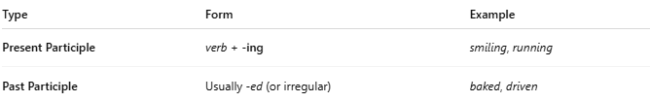
Type | Form | Example
Present Participle | verb + -ing | smiling, running
Past Participle | Usually -ed (or irregular) | baked, driven
🔹 These can act as adjectives in participial phrases.

🔸 Functions as Modifiers:
# Source: AI Source: Provided by: [Data Path: Persons Table -> ID Column: 1, Name_En Column: Motasem Essam] -> From: [Chatgpt (GPT‑5 Mini)] on [8/7/2025]
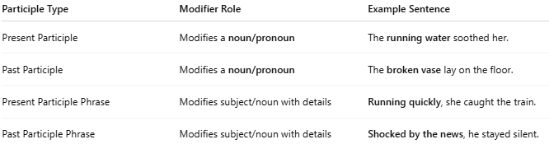
Participle Type | Modifier Role | Example Sentence
Present Participle | Modifies a noun/pronoun | The running water soothed her.
Past Participle | Modifies a noun/pronoun | The broken vase lay on the floor.
Present Participle Phrase | Modifies subject/noun with details | Running quickly, she caught the train.
Past Participle Phrase | Modifies subject/noun with details | Shocked by the news, he stayed silent.

🔸 Examples in Sentences:
# Source: AI Source: Provided by: [Data Path: Persons Table -> ID Column: 1, Name_En Column: Motasem Essam] -> From: [Chatgpt (GPT‑5 Mini)] on [8/7/2025]
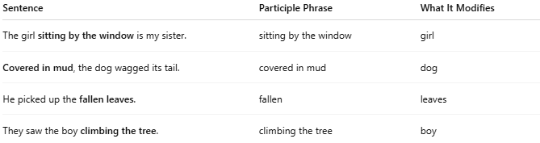
Sentence | Participle Phrase | What It Modifies
The girl sitting by the window is my sister. | sitting by the window | girl
Covered in mud, the dog wagged its tail. | covered in mud | dog
He picked up the fallen leaves. | fallen | leaves
They saw the boy climbing the tree. | climbing the tree | boy

